**BBM 121- PRINCIPLES OF MARKETING**

**QUESTION ONE (COMPULSORY) [30 MARKS]**

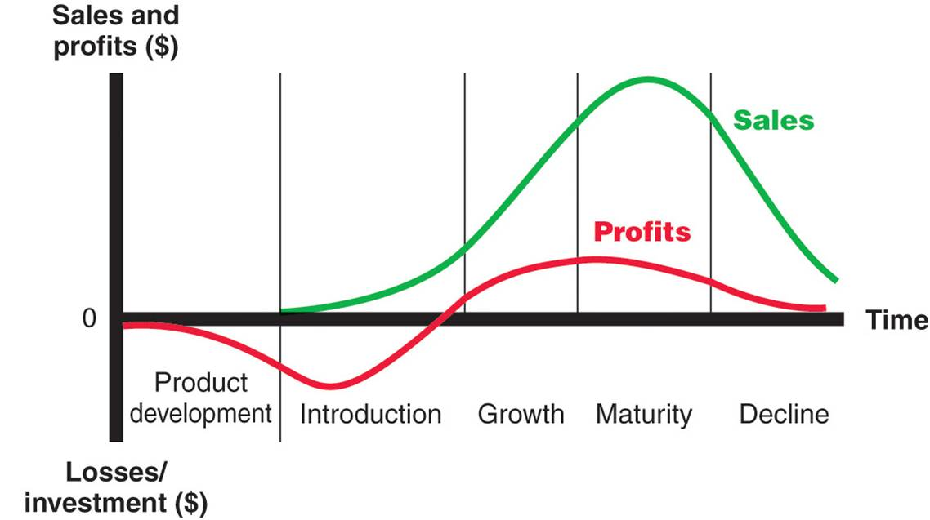

1. Study the above graph and answer the following questions;
2. Identify the graph. [1 Mark]
3. Highlight the stages at which Brand Differentiation and Competition begin. [2 Marks]
4. In what stages does every Business Owner want his/her offerings to dwell the longest and why? [4 Marks]
5. Explain the Profits between Product Development stage and Introduction stage. [3 Marks]
6. Explain the Market Positioning of the following offerings. [8 Marks]
7. *Garissa* University Brand
8. *Probox* Brand
9. *Bic* Biro Brand
10. *M-Pesa* Brand
11. Explain any two reasons why *Microsoft* is most successful at Mass Market Targeting while *Tecno* is not. [4 Marks]
12. Describe two global trend of dealing with Packaging waste. [4 marks]
13. Many local Business enthusiasts quite often get confused between the roles of Sales and Marketing in their businesses. Now, with clear examples describe what Marketing is all about. [4 Marks]

**QUESTION TWO [20 MARKS]**

1. Define the marketing environment (2 marks)
2. Discuss the factors that affect
3. Internal environment ( 6 Marks)
4. Tsk Environment (6 Marks)
5. Macro Environment ( 6 Marks)
6. With examples discuss three factors that affects internal, tasks and Macro environment
7. Begin by defining Marketing Environment then with specific examples discuss any three factors each from internal, task and macro environments. [20 Marks]

**QUESTION THREE [20 MARKS]**

1. Although Pricing decisions are complex and difficult, Price is the one element of the Marketing Mix that produces revenue while others produce cost. Discuss any five commonly used Pricing Strategies. [10 Marks]
2. Discus the five product Promotional Mix Elements. [10 Marks]

**QUESTION FOUR [20 MARKS]**

1. Describe any four factors that actively influence consumer behaviour. [8 Marks]
2. Discuss the buyer decision process. [6 mark]
3. Highlight any six Retailing Channels commonly used in Garissa. [6 marks]

**QUESTION FIVE [20 MARKS]**

1. The main objective of market positioning is to locate the offering in the mind of the customer in such a way as to maximise potential benefits. In lieu of this, discuss any five Market Positioning Strategies. [10 marks]
2. With relevant examples explain
3. Any three objectives which Packaging must achieve. [6 Marks]
4. Any two factors that enhance or encourage Product Packaging. [4 Marks]