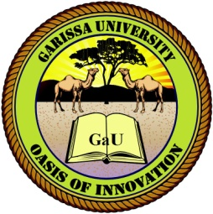
GARISSA UNIVERSITY

UNIVERSITY EXAMINATION 2018/2019 ACADEMIC YEAR THREE
SECOND SEMESTER EXAMINATION

SCHOOL OF BIOLOGICAL AND PHYSICAL SCIENCES

FOR THE DEGREE OF BACHELOR OF EDUCATION

COURSE CODE: STA 317

COURSE TITLE:

EXAMINATION DURATION: 2 HOURS

DATE: 03/02/2020 TIME: 09.00-11.00 AM

INSTRUCTION TO CANDIDATES

- The examination has FIVE (5) questions
- Question ONE (1) is COMPULSORY
- Choose any other TWO (2) questions from the remaining FOUR (4) questions
- Use sketch diagrams to illustrate your answer whenever necessary
- Do not carry mobile phones or any other written materials in examination room
- Do not write on this paper

This paper consists of TWO (2) printed pages please turn over

QUESTION ONE (COMPULSORY)

