GARISSA UNIVERSITY

UNIVERSITY EXAMINATION 2019/2020 ACADEMIC YEAR TWO
SECOND SEMESTER EXAMINATION

SCHOOL OF PURE AND APPLIED SCIENCES

FOR THE DEGREE OF BACHELOR OF EDUCATION

COURSE CODE: PHY 212

COURSE TITLE: WAVES AND OSCILLATIONS

EXAMINATION DURATION: 2 HOURS

DATE: 14/02/2020 TIME: 2.00-4.00 PM

INSTRUCTION TO CANDIDATES

- The examination has FIVE (5) questions
- Question ONE (1) is COMPULSORY
- Choose any other TWO (2) questions from the remaining FOUR (4) questions
- Use sketch diagrams to illustrate your answer whenever necessary
- Do not carry mobile phones or any other written materials in examination room
- Do not write on this paper

This paper consists of FOUR (4) printed pages please turn over

QUESTION ONE (COMPULSORY)
- State the superposition principle as used in wave phenomena [1 mark]
- Show that the velocity of sound in a gas is given by $v=\sqrt{\frac{E}{P}}$ where E is the bulk modules and ρ is the density of the gas [5 marks]
- Two identical piano strings of length 0.750 m are each tuned exactly to 440 Hz. The tension in one of the strings is then increased by 1.0%. If they are now struck, what is the beat frequency between the fundamentals of the two strings? [6 marks]
- A 200-g block connected to a light spring for which the force constant is 5.00 N/m is free to oscillate on a horizontal, frictionless surface. The block is displaced 5.00 cm from equilibrium and released from rest, as in Figure below
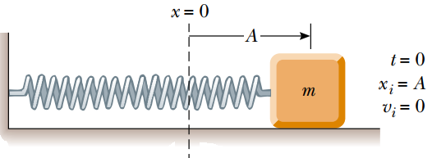
- Find the period of its motion [4 marks]
- Determine the maximum speed of the block [2 marks]
- What is the maximum acceleration of the block [2 marks]
- A 0.500-kg cart connected to a light spring for which the force constant is 20.0 N/m oscillates on a horizontal, frictionless air track.
- Calculate the total energy of the system and the maximum speed of the cart if the amplitude of the motion is 3.00 cm [4 marks]
- What is the velocity of the cart when the position is 2.00 cm? [3 marks]
- Compute the kinetic and potential energies of the system when the position is 2.00 cm [3 marks]

QUESTION TWO
- A sinusoidal wave traveling in the positive x direction has amplitude of 15.0 cm, a wavelength of 40.0 cm, and a frequency of 8.00 Hz. The vertical position of an element of the medium at t = 0 and x = 0 is also 15.0 cm.
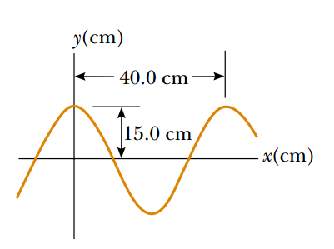
- Find the wave number k, period T, angular frequency $ω$, and speed v of the wave. [5 marks]
- Determine the phase constant $φ$, and write a general expression for the wave function [5 marks]
- The variation in the gas pressure $ΔP$ measured from the equilibrium value is also periodic. And can be expressed as $∆P={∆P}_{max}sin⁡(κx-ωt)$ [10 marks]

QUESTION THREE
- A particle rotates counterclockwise in a circle of radius 3.00 m with a constant angular speed of 8.00 rad/s. At t = 0, the particle has an x coordinate of 2.00 m and is moving to the right
- Determine the x coordinate as a function of time [5 marks]
- Find the x components of the particle’s velocity and acceleration at any time t [5 marks]
- The string is driven at a frequency of 5.00 Hz. The amplitude of the motion is 12.0 cm, and the wave speed is 20.0 m/s. Determine the angular frequency $ω$ and wave number k for this wave, and write an expression for the wave function [5 marks]
- Show that the total mechanical energy of a simple harmonic oscillator is a constant of the motion and is proportional to the square of the amplitude [5 marks]

QUESTION FOUR
- A laser in a compact disc player generates light that has a wavelength of 780 nm in air.
- Find the speed of this light once it enters the plastic of a compact disc (n = 1.55) [3 marks]
- What is the wavelength of this light in the plastic? [3 marks]
- A submarine (sub A) travels through water at a speed of 8.00 m/s, emitting a sonar wave at a frequency of 1 400 Hz. The speed of sound in the water is 1 533 m/s. A second submarine (sub B) is located such that both submarines are traveling directly toward one another. The second submarine is moving at 9.00 m/s.
- What frequency is detected by an observer riding on sub B as the subs approach each other? [7 marks]
- As the two submarines recede from each other, the observer in sub B hears the frequency [7 marks]

QUESTION FIVE
- An object oscillates with simple harmonic motion along the x axis. Its position varies with time according to the equation $x=(4m)cos\left(πt+\frac{π}{4}\right)$
- Determine the amplitude, frequency, and period of the motion. [4 marks]
- Calculate the velocity and acceleration of the object at any time t. [4 marks]
- Consider a traveling wave propagating along a string that is under a tension T. Show that the differential equation called the linear wave equation is often written in the form $\frac{∂^{2}y}{{∂x}^{2}}=\frac{1}{v^{2}}\frac{∂^{2}y}{{∂t}^{2}}$ [12 marks]

