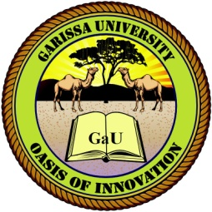
GARISSA UNIVERSITY

UNIVERSITY EXAMINATION 2019/2020 ACADEMIC YEAR FOUR
SECOND SEMESTER EXAMINATION

SCHOOL OF PURE AND APPLIED SCIENCES

FOR THE DEGREE OF BACHELOR OF EDUCATION

COURSE CODE: CHE 412

COURSE TITLE: CHEMISTRY OF NATURAL PRODUCTS

EXAMINATION DURATION: 2 HOURS

DATE: 14/02/2020 TIME: 2.00-4.00 PM

INSTRUCTION TO CANDIDATES

- The examination has FIVE (5) questions
- Question ONE (1) is COMPULSORY
- Choose any other TWO (2) questions from the remaining FOUR (4) questions
- Use sketch diagrams to illustrate your answer whenever necessary
- Do not carry mobile phones or any other written materials in examination room
- Do not write on this paper

This paper consists of THREE (3) printed pages please turn over

QUESTION ONE (COMPULSORY)
- Define the following terms: [5 marks]
- Biosynthesis
- Bioassay
- Natural products
- Pharmacognosy
- Biomimetic synthesis
- Describe any four biosynthetic pathways leading to the major classes of natural products [4 marks]
- (i) What are steroids? [1 mark]
(ii) Give three examples of steroids. [3 marks]
- Name four methods used in the isolation and purification of natural products. [4 marks]
- The ease with which the active agents in natural products can be isolated and purified depends on various factors. Name at least three of these factors. [3 marks]
- Distinguish between synergistic and antagonistic activity of isolates of natural products. [2 marks]
- State and explain two spectroscopic techniques employed in structural characterization of an isolated natural product. [4 marks]
- Explain four pharmaceutical importances of carbohydrates. [4 marks]

QUESTION TWO
- Briefly describe three basic stages of isolation of natural products from plants. [3 marks]
- Give a brief discussion of flavonoids under the following sub headings:
- Structure [2 marks]
- Occurrence [2 marks]
- Classifications [3 marks]
- Stages of biosynthetic pathway [4 marks]
- Tropinone, an alkaloid which is a synthetic precursor to Atropine (isolated from the plant Atropa belladonna) can be synthesized biomimetically as shown below:

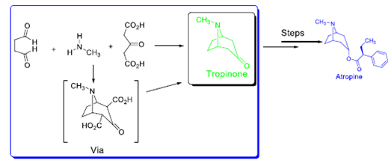
Show the reaction mechanism of the biomimetic synthesis of Tropinone. [6 marks]

QUESTION THREE
- Distinguish between primary metabolites and secondary metabolites. Give two examples of each. [5 marks]
- State four uses of natural products. [6 marks]
- State three disadvantages associated with synthetic drugs. [3 marks]
- Distinguish between in vivo and in vitro evaluation. [2 marks]
- State two reasons as to why separation of pure state compounds from natural sources involves laborious and elaborate processes. [2 marks]
- Name the vitamins associated with the following conditions:
- Ricket [1 mark]
- Cancer [1 mark]

QUESTION FOUR
- What are anthocyanins [1 mark]
- State three roles played by primary metabolites in plant life. [3 marks]
- Name any 2 examples of alkaloids. [2 marks]
- Describe any two methods of biological assays. [4 marks]
- Briefly discuss cholesterol under the following subheadings:
- Structure [2 marks]
- Occurrence [2 marks]
- Human bodily function [2 marks]
- Stages of biosynthetic pathway [4 marks]

QUESTION FIVE
- What are Vitamins? [2 marks]
- How are tannins classified? [2 marks]
- Briefly discuss properties of tannins [4 marks]
- Briefly discuss four chemical tests for tannins [12 marks]

