GARISSA UNIVERSITY

UNIVERSITY EXAMINATION 2019/2020 ACADEMIC YEAR TWO
SECOND SEMESTER EXAMINATION

SCHOOL OF SCHOOL OF PURE AND APPLIED SCIENCES

FOR THE DEGREE OF BACHELOR OF EDUCATION

COURSE CODE: PHY 222e
COURSE TITLE: PROPERTIES OF MATTER

EXAMINATION DURATION: 2 HOURS

DATE: 16/12/2020 TIME: 12.00-2.00 PM

INSTRUCTION TO CANDIDATES

- The examination has FIVE (5) questions
- Question ONE (1) is COMPULSORY
- Choose any other TWO (2) questions from the remaining FOUR (4) questions
- Use sketch diagrams to illustrate your answer whenever necessary
- Do not carry mobile phones or any other written materials in examination room
- Do not write on this paper

This paper consists of SEVEN(7) printed pages please turn over

Relevant information (You may find this constants useful)
Avogadro constant(N_{A}) 6.0 x 10²⁶mol⁻¹
Boltzmann’s constant (K_{B}) 1.38 x 10⁻²³JK⁻¹
Gravitational intensity(g) 9.81Nkg⁻¹
Molecular weight of NaCl 58.2g/mole
Surface tension of water($γ)$ 7.28 x 10⁻²Nm⁻¹
Universal gas constant(R) 8.315Jmol⁻¹K⁻¹
1gm molecule of any gas weighs M x 10⁻³ Kg where M is the molecular/atomic weight

QUESTION ONE
a. i. Distinguish between an ideal gas and a real gas. [3 marks]
ii. Define the following terms [2 marks]
- Crystalline solids
- Unit cell
iii. Based on the illustrations below in fig.1 briefly discuss the importance of the structure of materials. [3 marks]
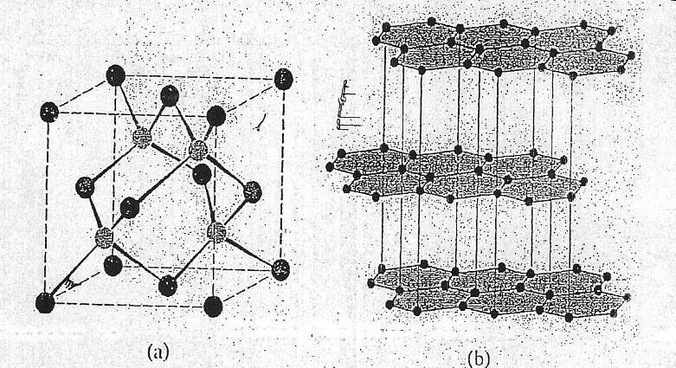 Fig. 1

b. i.Name four common types of bonds encountered in solids. [2 marks]
ii.State two reasons why amorphous solids are formed. [2 marks]
iii.Calculate the root mean square velocity for a hydrogen gas molecule. [3 marks]

c. i. Acapillary tube with an inside diameter of 250$μ$m can support a 100mm column of
liquid that has a density of 930kg.m⁻³. The observed contact angle is 15⁰. Find the surface tension of the liquid. [3 marks]
ii. State Bragg’s law of diffraction and give two geometrical facts that are necessary for the derivation of the law. [2 marks]
iii. State assumptions of the ideal gas law. [3 marks]

d. i. Prove that the mean translational kinetic energy, E of a molecule is given as; [3 marks]
E = $\frac{3}{2} kT$

Where k = $\frac{R}{N_{A}}$ , the Boltzmanns constant.

ii. The mean transitional Energy of an oxygen molecule at 200 ⁰C is found to be
7.5 x 10⁻²¹J. Calculate the mean speed and mean translational kinetic energy of oxygen molecule at a temperature of 200 ⁰C. [4 marks]
- Molar mass of oxygen = 0.032kg/mol

QUESTION TWO
a. i. Both crystals and glasses are bonafide solids and share the essential attribute of the solid state. What would you consider to constitute their fundamental difference?
[2 marks]
ii. Briefly describe the nature of interatomic forces and how they act. [2 marks]

iii. As an ideal gas undergoes an isothermal (constant temperature) expansion at
temperature T, its volume changes from V₁ to V₂. How much work does the gas do? [3 marks]
b. i. State characteristics of an ideal gas. [2 marks]
ii. Give two applications of liquid crystals. [2 marks]

iii. Fig.2 below shows molecules arrangement in liquid crystals. Identify the phases shown and state their salient characteristics. [4 marks]

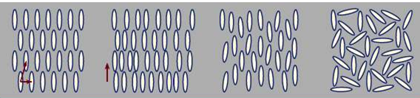 A. B. C. D.
Fig.2; Arrangement of Molecules in Liquid Crystal.

c. i. Distinguish between isotropic and Anisotropic molecules. [2 marks]
ii. The formation of a solid would normally involve cooling of vapour of the material until it condenses into the liquid state and then further gradual cooling of the liquid till it solidifies. The curve below shows cooling path of assembly atoms in a solid state.
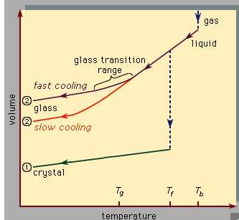Fig.3
Compare and contrast the nature of the two types of solids. [3marks]

QUESTION THREE
a. i. What makes a gas real (deviate from perfect)? [2 marks]
ii. When a weather balloon is filled with hydrogen gas at 1.000 atm. pressure and 25⁰C it has a diameter of 3.00m and a volume of 14,100 litres. At high altitude the atmospheric pressure drops to half at sea level value; the temperature is -40⁰C. What is the volume of the balloon and its diameter? [3 marks]

b. i. The Leonard Jones potential energy function for the force between two particular ions, carrying charges +e and —e respectively, is written as below

V = $-\frac{A}{r^{m}}+\frac{B}{r^{n}}$

Use the figure below to explain the shape of the curve clearly defining the constants
A, B, n and m. [4 marks]
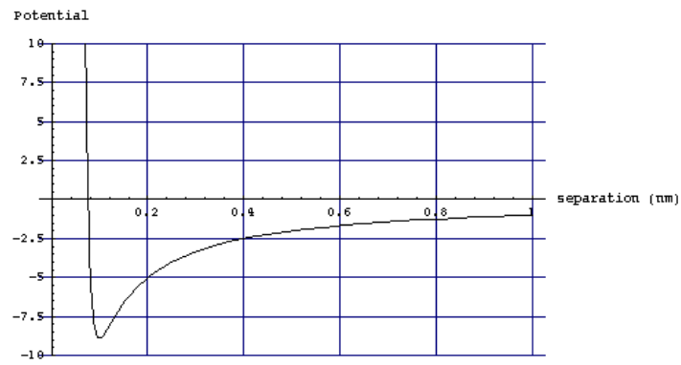Fig.4
ii.With the aid of an example define Negative Electrical Potential theory. [2 marks]

c. i. State three assumptions of kinetic molecular theory. [3 marks]
ii. What do you understand by an equation of state? Prove that from the ideal gas equation, pressure, P is given as; [3 marks]
P = ρRT
iii. At high temperatures there’s a tendency for glasses to change shape into a sphere.
The surface energy of a glass at 650 ⁰C is 0.3Jm⁻². If the glass changes, from a
cylinder of length 100mm and diameter 20µm, into a sphere, find the energy
released. [3 marks]

QUESTIONS FOUR

a. i.With the aid of an example define a primitive unit cell. [2 marks]

ii. In ionic solids the value of energy needed to move an atom completely from its equilibrium is given as
F = $\frac{A}{r^{m}}-\frac{B}{r^{n}}$
Show that the cohesive energy of ionic solid per molecule is given by
Dissociation energy = cohesive energy, PE = $\frac{Ae^{2}}{4πε_{0}r_{0}} \left[1- \frac{1}{n}\right]$ [5 marks]

b. i. Define specific heat capacity. [1 marks]
ii. A vessel contains 2.0g of helium gas at 27⁰C. Given that the relative atomic mass of helium is 4.0 and that $γ$ = 1.07 for helium. Determine the specific heat capacity of the gas. [3 marks]
iii. The inter atomic potential U as a function of the inter atomic spacing d is shown below for two distinct materials “1” and “2”. Both materials have an identical cubic structure.
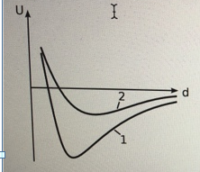 Fig.5

Which of the two materials have a larger lattice constant (lattice parameter) a and Which has a smaller linear thermal expansion coefficient a? Explain [2 marks]

c. i. Define the term Bravais lattice. [1 mark] ii.Using the 3-dimensional crystal lattice of NaCl derive the madelung constant.
[3 marks]
iii. A fixed mass of a gas has a volume V when the temperature is 127⁰C. To what temperature must the gas be raised so that its volume increases to 2.75 V with pressure remaining constant. [3 marks]

QUESTION FIVE

a. i. What are Miller indices. [2 marks]

ii.A crystal lattice intercepts the x, y, z axes at (3,4,2). Determine the miller indices of this plane. [3 marks]
b. i. Define surface energy. [1 mark]
ii. Evaluate the effect of temperature on surface energy. [3 marks]
iii. A razor blade inserted into the edge of a thin sheet of mica in high vacuum drives a crack to an equilibrium length along the central cleavage plane parallel to the sheet faces. The surface energy is measured as 5.0Jm-s when air is let in, then the crack length increases 1.9 times. Find the surface energy of mica in air [3 marks]

c. i. What do you understand by capillary action. [1 mark]
ii. The figure below shows a gas bubble in a liquid. Show that the pressure difference for a gas bubble in a liquid is given as; [4 marks]
(P_{gas} – P_{liquid}) = $\frac{2T}{R}$ where T is the surface tension and R the radius.

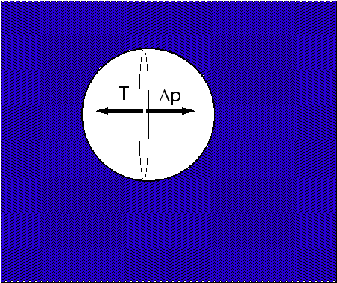 Fig.6

iii. A bubble of air has a diameter of 1mm when it is 0.5m under the surface of water (surface tension 73mNm⁻¹). Find the gauge pressure inside the bubble. [3 marks]

