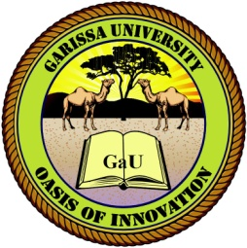
GARISSA UNIVERSITY

UNIVERSITY EXAMINATION 2019/2020 ACADEMIC YEAR TWO
SECOND SEMESTER EXAMINATION

SCHOOL OF SCHOOL OF PURE AND APPLIED SCIENCES

FOR THE DEGREE OF BACHELOR OF EDUCATION

COURSE CODE:

COURSE TITLE:

EXAMINATION DURATION: 2 HOURS

DATE: 11/12/2020 TIME: 03.00-05.00 PAM

INSTRUCTION TO CANDIDATES

- The examination has FIVE (5) questions
- Question ONE (1) is COMPULSORY
- Choose any other TWO (2) questions from the remaining FOUR (4) questions
- Use sketch diagrams to illustrate your answer whenever necessary
- Do not carry mobile phones or any other written materials in examination room
- Do not write on this paper

This paper consists of TWO (2) printed pages please turn over

QUESTION ONE (COMPULSORY)

