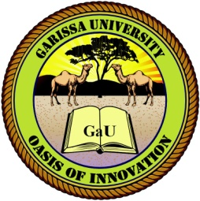
GARISSA UNIVERSITY
UNIVERSITY EXAMINATION 2018/2019 ACADEMIC YEAR FOUR
FIRST SEMESTER EXAMINATION

SCHOOL OF BUSINESS AND ECONOMICS

FOR THE DEGREE OF BACHELOR OF BUSINESS MANAGEMENT

COURSE CODE: BBM 442

COURSE TITLE: INTERNATIONAL PURCHASING

EXAMINATION DURATION: 2 HOURS

DATE: 03/12/18 TIME: 3.00-5.00 PM

INSTRUCTION TO CANDIDATES

- The examination has FIVE (5) questions
- Question ONE (1) is COMPULSORY
- Choose any other TWO (2) questions from the remaining FOUR (4) questions
- Use sketch diagrams to illustrate your answer whenever necessary
- Do not carry mobile phones or any other written materials in examination room
- Do not write on this paper

This paper consists of TWO (2) printed pages please turn over

QUESTION ONE (COMPULSORY)
- Define the following
- International Purchasing [2 marks]
- Global sourcing [2 marks]
- Negotiations [2 marks]
- reciprocal purchasing [2 marks]
- letter of credit [2 marks]
- Describe the payment methods in global purchasing transactions [8 marks]
- Discuss the rights of global logistics [12 marks]

QUESTION TWO
- Describe four main types of letters of credit [8 marks]
- Describe the costs related to global sourcing [12 marks]

QUESTION THREE
- Describe the phases of negotiation in purchasing [5 marks]
- Discuss the major types of counter-trade an organization can be involved in [15 marks]

QUESTION FOUR
- Describe reasons why governments implement tariffs [5 marks]
- Discus ethical issues associated with international purchasing [15 marks]

QUESTION FIVE
- Discuss major documentations in international purchasing [10 marks]
- Discuss benefits of international purchasing to an organization [10 marks]

