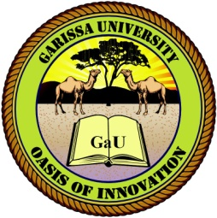
GARISSA UNIVERSITY

UNIVERSITY EXAMINATION 2017/2018 ACADEMIC YEAR ONE
THIRD SEMESTER EXAMINATION

SCHOOL OF BUSINESS AND ECONOMICS

FOR THE DEGREE OF MASTER OF BUSINESS ADMINISTRATION

COURSE CODE: MBA 850

COURSE TITLE: HUMAN RESOURCE DEVELOPMENT

EXAMINATION DURATION: 2 HOURS

DATE: 07/08/18 TIME: 2.00-5.00 PM

INSTRUCTION TO CANDIDATES

- The examination has FIVE (5) questions
- Question ONE (1) is COMPULSORY
- Choose any other THREE (3) questions from the remaining FOUR (4) questions
- Use sketch diagrams to illustrate your answer whenever necessary
- Do not carry mobile phones or any other written materials in examination room
- Do not write on this paper

This paper consists of TWO (2) printed pages please turn over

QUESTION ONE (COMPULSORY)
- Explain five aims of strategic learning and development in an organization. [5 marks]
- Describe the philosophy underpinning strategic learning and development in an organization [5 marks]
- State five potential benefits that accrue after investing in learning and development in an organization and individual employees [5 marks]

QUESTION TWO
- Explain any five steps of Reynolds (2004), required to create a learning culture [10 marks]
- Enumerate five things that learning organizations are good at doing according to Garvin (1993) [5 marks]

QUESTION THREE
- Explain five differences between Human resource management and human resource development [10 marks]
- State any five needs and significance of human resource development in an organization [5 marks]

QUESTION FOUR
- What do you understand by career planning? Describe any five of its objectives [10 marks]
- State the five planning process that a human resource manager may follow in assisting the employees in their career progression. [5 marks]

QUESTION FIVE
- (i) what is human capital [1 mark]
(ii) Describe in detail the three constituents of human capital. [6 marks]
- Explain the four significance of human capital theory. [8 marks]

