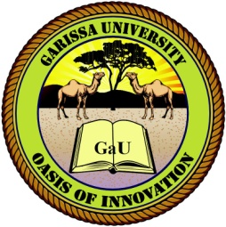
GARISSA UNIVERSITY

UNIVERSITY EXAMINATION 2017/2018 ACADEMIC YEAR ONE
FIRST SEMESTER EXAMINATION

SCHOOL OF BUSINESS AND ECONOMICS

FOR THE DEGREE OF MASTER OF BUSINESS ADMINISTRATION

COURSE CODE: MBA

COURSE TITLE:

EXAMINATION DURATION: 2 HOURS

DATE: /08/18 TIME: .00-.00 PM

INSTRUCTION TO CANDIDATES

- The examination has FIVE (5) questions
- Question ONE (1) is COMPULSORY
- Choose any other TWO (2) questions from the remaining FOUR (4) questions
- Use sketch diagrams to illustrate your answer whenever necessary
- Do not carry mobile phones or any other written materials in examination room
- Do not write on this paper

This paper consists of TWO (2) printed pages please turn over

QUESTION ONE (COMPULSORY)

